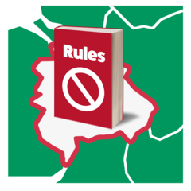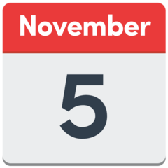

New Rules from 5th November

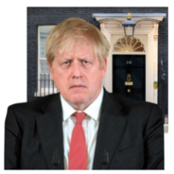

More people have Covid-19. Boris said we must keep safe.

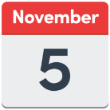

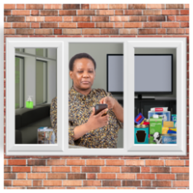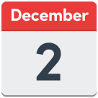 Boris said from 5th November until 2nd December we must stay at home to help control the virus.

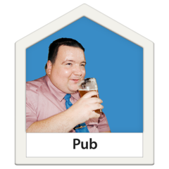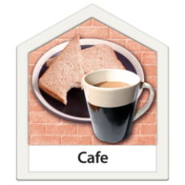

Pubs, cafés and restaurants will be closed.

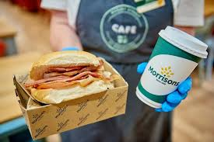

You may be able to get a takeaway from some places.



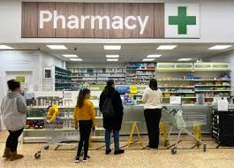Food shops, chemists and some other shops will stay open.

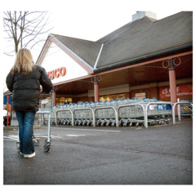You can go out:

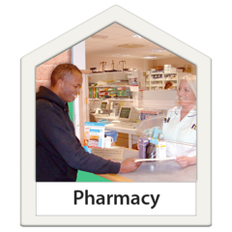

* For food
* For medicines
* 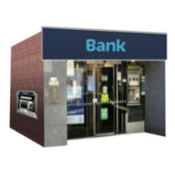To get money or pay in money to a bank

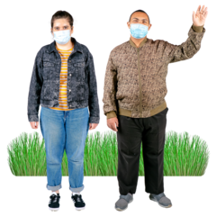

You can meet with 1 other person outside to exercise.

You must keep safe and follow the rules:

* 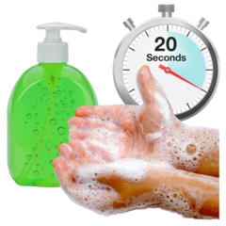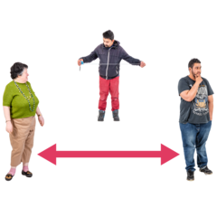Keep 2 meters apart
* Wash your hands as soon as you get home

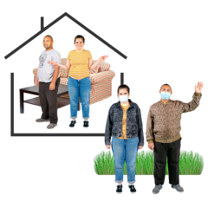

Do not meet with anybody inside your home unless you live with them or they are in your support bubble.

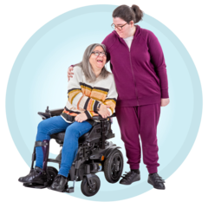

If you live on your own, you can meet with somebody you do not live with. This is called a support bubble.

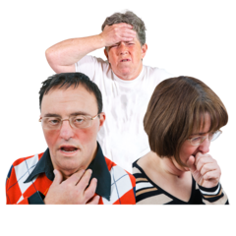If you feel unwell and have:

* A new cough
* High temperature
* No taste or smell

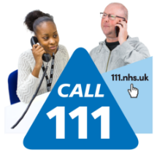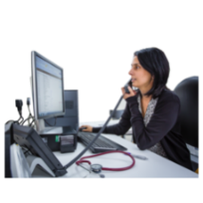

Phone your doctor surgery or 111

If you live in the Greenwich Borough and need help you can phone:

CLDT

CLDT: [**020 8921 4860**](tel:02089214860).

Greenwich Community Hub:

**0800 470 4831**